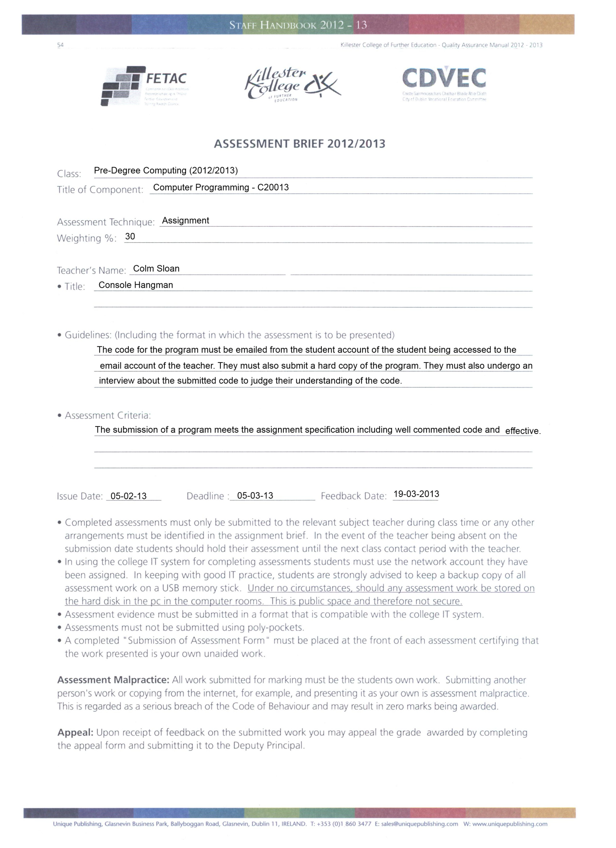

Programming in C Assignment

**Deadline**: 05-03-2013 before 9:00pm

**Marking Schedule**: 90 total marks

* Clearly documented program code – 15 marks
  + what the code does AND how it does it
  + in this case, let the comments be the documentation
* Excellent screen layout – 15 marks
  + console output should be information, neat and readable
* Effective code layout – 15 marks
  + following the style guide (<http://google-styleguide.googlecode.com/svn/trunk/cppguide.xml>)
  + e.g. proper indentation, spacing, brace placement etc.
* Accurate programming (syntactically and semantically) – 30 marks
  + marks for each step in the process that works
  + try to repeat code as little as possible
  + prefer simple solutions
  + minimizes processing and memory requirements
* Appropriate testing – 15 marks
  + Validate user input i.e. warn user for every possible mistaken input they can give e.g. too high an index, too low an index etc.

**Assignment**:

Hangman is a game in which a word is selected by one player, referred to as the selected word, and another player, referred to as the user, must guess that word by guessing letters that may be in the word. The user wins the game if he guesses all letters correctly before he runs out of lives. A life is lost for every time the user guesses a letter that isn’t present in the selected word. The user loses the game when he runs out of lives. The rules of hangman are found here: <http://en.wikipedia.org/wiki/Hangman_(game)>

The selected word should be chosen at random from a list of words in a file. The word being guessed should be visible in the console at all times. Letters that have not been guessed should be shown as hyphens. Correctly guessed letters should be shown as they appear in the word. For example, if the selected word is “hobbie” and the user has guessed only the letter ‘b’ correctly, the word displayed should appear as “--bb--”. The number of lives the user has left should be visible in the console at all times too. Incorrectly guessed letters should be visible at all times. The selected word should be stored as a (c string) character array, as should the incorrectly guessed letters. The user should have three lives when the game begins.

User input should be validated. Input must not be longer than one character. Input must not be a number. All functions from the standard library can be used. Your program must include at least one function other than the main function. Use of functions is encouraged as to increase code readability.

**Submission**:

E-mail program code and hand in a printed copy of the code by the deadline. Each student will undergo an interview about their code to make sure they understand it. Results will be received within three weeks of submission (before 19-03-2013).